EXP. NO: 6 : GENERATION AND ANALYSIS OF FREQUENCY MODULATED (FM) AND OF PHASE MODULATED (PM) SIGNALS USING MATLAB
NAME:V.RUSHMITHA
DATE:
Objectives:
To generate and analyze Frequency Modulated (FM) and Phase Modulated (PM) signals using
MATLAB by varying the instantaneous frequency and phase of a carrier signal in accordance
with the message signal.
Procedure
1. Open MATLAB and create a new script file.
2. Define the simulation parameters, including the sampling frequency, time vector, message
frequency, carrier frequency, message amplitude, and carrier amplitude.
3. Generate the message signal using a low-frequency sinusoidal waveform.
4. Generate the carrier signal using a high-frequency sinusoidal waveform.
5. Generate the Frequency Modulated (FM) signal by varying the instantaneous frequency of the
carrier in accordance with the message signal and the selected frequency modulation index.
6. Generate the Phase Modulated (PM) signal by varying the instantaneous phase of the carrier
according to the message signal and the selected phase modulation index.
7. Plot the message signal, carrier signal, FM signal, and PM signal using MATLAB subplots.
8. Observe and compare the time-domain waveforms of the FM and PM signals with the original
message signal.
9. Analyze the variation in the instantaneous frequency of the FM signal and the instantaneous
phase of the PM signal due to changes in the message signal.
10. Compare the characteristics of FM and PM signals by studying their modulation behavior and
waveform variations.
11. Verify the successful generation of FM and PM signals based on the simulation results.
PROGRAM (MATLAB CODE)
clc;
clear;
close all;
Am=1;
Ac=1;
fm=5;
fc=50;
beta=5;
kp=5;
fs=1000;
t=0:1/fs:1;
m = Am*cos(2*pi*fm*t); % Message signal c = Ac*cos(2*pi*fc*t); % Carrier signal
fm_sig = Ac*cos(2*pi*fc*t + beta*sin(2*pi*fm*t)); % FM
pm_sig = Ac*cos(2*pi*fc*t + kp*m); % PM
Df = beta*fm; % Frequency deviation
fprintf('Frequency Deviation = %d Hz\n',Df);
fprintf('FM Modulation Index = %d\n',beta);
subplot(4,1,1), plot(t,m), title('Message Signal')
subplot(4,1,2), plot(t,c), title('Carrier Signal')
subplot(4,1,3), plot(t,fm_sig), title('FM Signal')
subplot(4,1,4), plot(t,pm_sig), title('PM Signal')
OUTPUT GRAPH
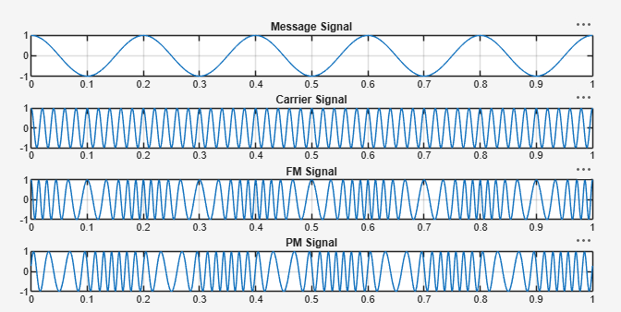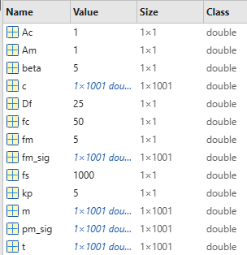

Result
The Frequency Modulated (FM) and Phase Modulated (PM) signals were successfully
generated using MATLAB by varying the instantaneous frequency and phase of the carrier
signal according to the message signal.
• Frequency Deviation (Δf) = 25 Hz
• FM Modulation Index (β) = 5

